IOT-ENVIRONMENTAL MONITORING

## NAME:A.Suji

## ID:aut962921104711

## Email:suji76531@gmail.com

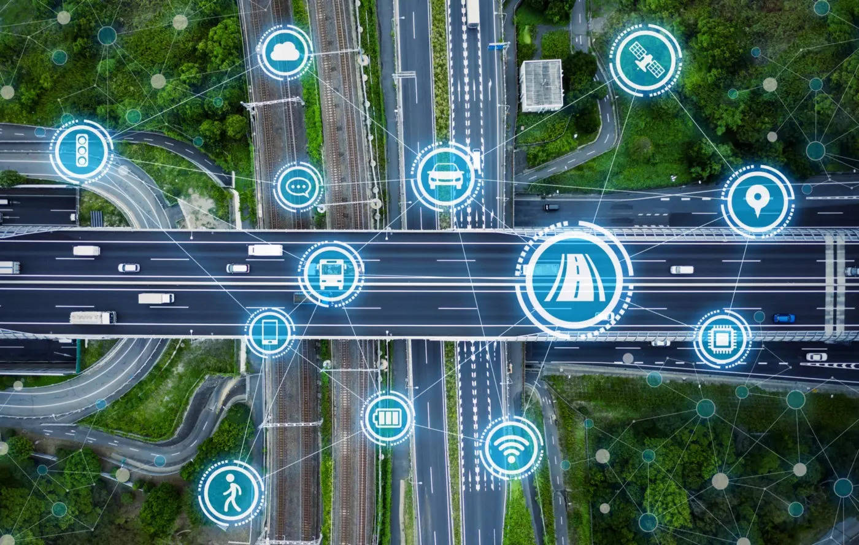

TABLES OF CONTENTS

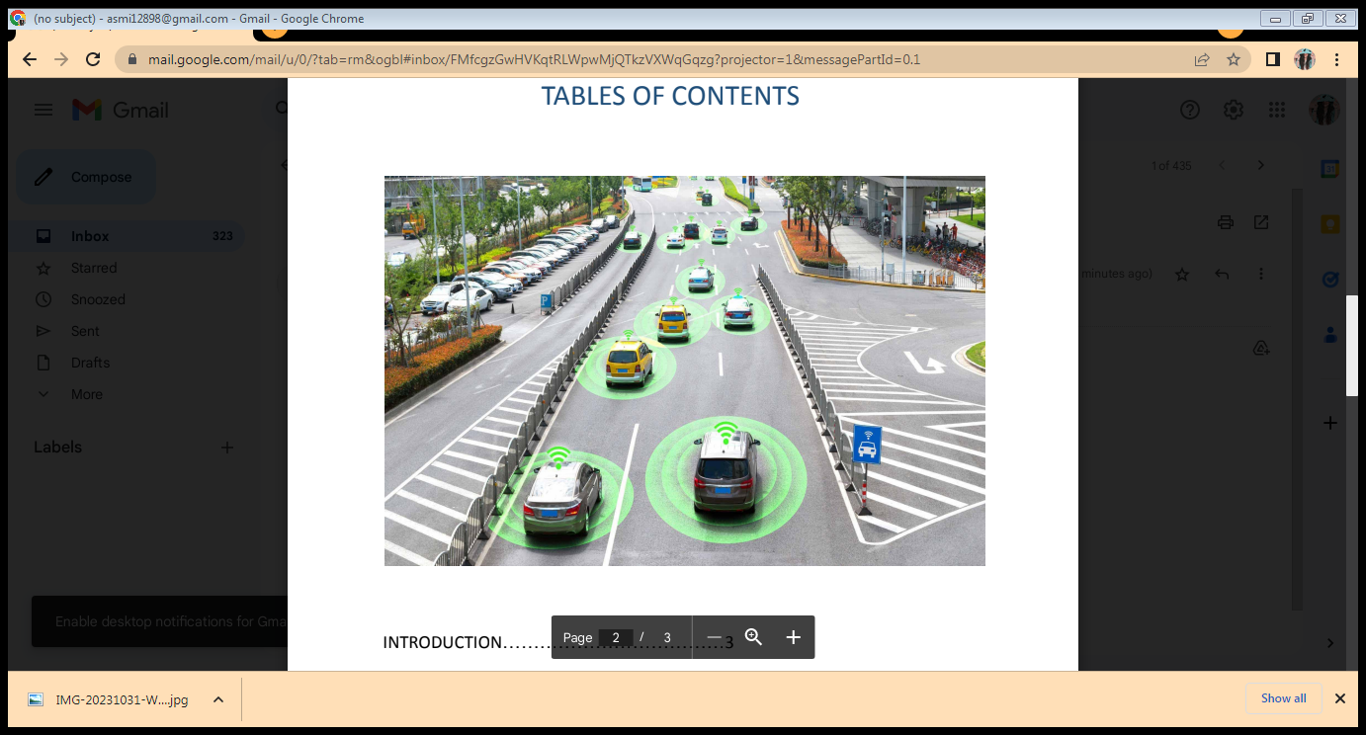

INTRODUCTION....................................3

OVERALL DESIGN..................................4

SOFTWARE DESIGN..............................5

SYSTEM TESTING..................................6

JAVA SCRIPT...........................................6

CONCLUSION........................................1

### DEVELOPMENT PART1

## Start building the IOT enabled traffic management in road

**1.INTRODUCTION:**

Traffic management is the organisation, arrangement, guidance and control of both stationary and moving traffic, including pedestrians, bicyclists and all types of vehicles. Its aim is to provide for the safe, orderly and efficient movement of persons and goods, and to protect and, where possible, enhance the quality of the local environment on and adjacent to traffic facilities. This book is an introduction to traffic management, written in laypersons' language, and assuming no background knowledge of the subject. Various basic traffic characteristics relating to road users, vehicles and roads, and traffic regulation and control, are discussed, including some traffic volume and traffic flow considerations relevant to traffic management.

For effective traffic management, it is essential that the practitioner works from factual information. Road inventory and statistical methods, and the more common types of traffic studies, including traffic volume and composition, origin and destination, speed, travel time and delay, accidents and parking are described. "Before and after" studies, and estimation of future traffic are also covered. As a basis for logically applying traffic management techniques it is necessary to develop a classification or hierarchy of all roads to ensure that the primary purpose of each of them is defined, agreed and understood. A functional classification of roads suitable for traffic management purposes, and a process for developing such a system is described. Several chapters go on to discuss various aspects of traffic management, including signing and delineation, pedestrian facilities, bicycle facilities, intersections, traffic signals, road capacity, parking, roadside safety and roadway lighting. The objectives of local area traffic management schemes, and a systematic process for developing them are described, and the various techniques that may be used and the principles of design of traffic management devices are summarized.

**2.OVERALL DESIGN:**

2.1overall structure of the system

Traffic management plays an important role in city planning and regulating the density of vehicles on the road. For effective traffic management, vehicle classification and vehicle counting are the key modules that serve as a base for almost all the use cases built for traffic analysis. Classification and counting of vehicles, both moving and stationary, are done by applying image processing (video content analysis) algorithms on video streams taken from a stationary camera.

This white paper proposes an effective approach for moving vehicle classification followed up by vehicle counting, for classified types of vehicles. This data helps in strategic city planning, and in generating meaningful insights for improving efficiency and reliability in Traffic Management.

2.2 sensor selection and circuit design:

Over the last decade, sensor technology has become ubiquitous and has attracted a lot of attention. Sensors have been deployed in many areas such as healthcare [7,8], agriculture [9,10], and forest [11,12], vehicle and marine [13,14] monitoring. In transportation, sensor technology supports the design and development of a wide range of applications for traffic control, safety, and entertainment. In recent years, sensors, and actuators such as tire pressure sensor and rear-view visibility systems have become mandatory (due to federal regulation in the United States [15]) in the manufacturing of vehicles and the implementation of intelligent transportation systems, aimed at providing services to increase drivers’ and passengers’ satisfaction, improve road safety and reduce traffic congestion.

Controller solution:

Emergency Routing Control:

When traffic safety emergencies occur, first responders must arrive quickly and safely to the scene. Smart traffic management uses congestion data and vehicle location to adapt road routing and traffic signal timing to ensure emergency vehicles can arrive fast. Additionally, Digi FirstNet Ready™ cellular routers utilize Band 14 to deliver priority and pre-emptive communications for first responders.

Adaptive Traffic Control:

Today, cities can be much more strategic in their user implementation of traffic systems to manage their city road congestion. Adaptive control adds the "smart" to smart traffic management. Using sensors, traffic cameras and fast, reliable cellular communications, adaptive control systems detect vehicle congestion areas, which triggers changes to traffic safety signal timing to optimize traffic throughput in real time.

Backhaul Communications:

A critical communications network for smart traffic management must include high quality, high availability backhaul communications between the communication hub, or "traffic management center" (TMC) and the components across the network. Digi provides guidance on establishing concurrent cellular and fiber links and other strategies for continuous, reliable communications with the TMC provider

Connected Vehicle Systems:

Connected vehicle technology is designed to prevent collisions between automobiles, transit systems and pedestrians. Municipalities are installing the critical infrastructure for this smart city strategy now. In doing so, they can take advantage of some of its key benefits. Digi can help you plan and deploy connected vehicle technology as part of your Intelligent Transportation Systems (ITS) and traffic management plan.

Public Transit Systems:

Smart traffic control management systems are not only designed to route emergency vehicles, commuters and other city vehicle traffic, but they also integrate with the city public transport transit systems. Traffic signal timing is adjusted to maintain schedules of transit buses and light rail. These user systems can be automated and managed by system administrators at the Traffic Management Center for optimal routing.

Simplified Infrastructure Provider:

Traffic management systems today rely on a range of technologies, from analog lines to twisted pair, private radio and copper. Municipalities are moving to cellular networks for faster, more reliable, robust and cost-effective connectivity that can support the entire range of traffic systems from traffic cameras and routing applications to connected vehicle technology. Digi cellular solutions integrate them all.

3. software design:

3.1 software flow:

Traffic management software offers tools for governments, municipalities, and organizations to manage vehicle traffic in cities and areas by offering traffic analytics, sensor data, traffic simulation, traffic monitoring, traffic planning, and more. Compare the best Traffic Management software currently available using the table below.

4.system testing:

complexity It’s difficult to adequately test complex systems. But what’s really difficult is keeping a system adequately tested. Creating systems that do what they are designed to do is hard but, even with the of these systems, many life critical systems have the engineering and production testing investment behind them to be reasonably safe when deployed. Its keeping them adequately tested over time as conditions and the software system changes where we sometimes fail.

There are exceptions to the general observation that we can build systems that operate safely when inside reasonable expectations of expected operating conditions. One I’ve written about was the Fukushima Dai-1 nuclear catastrophe. Any reactor design that doesn’t anticipate total power failure including backups, is ignoring considerable history. Those events, although rare, do happen and the life critical designs need to expect them and this fault condition needs to be tested in a live production environment. “Nearly expected” events shouldn’t bring life critical systems. The more difficult to protect against are 1) the impact of black swan events and 2) the combination of vastly changing environmental conditions over time

5.Java script:

It is very simple to create a traffic light application using javascript.

function startTrafficSignal () {

var green=document.getElementById("green");

var red=document.getElementById("red");

var yellow=document.getElementById("yellow");

green.style.opacity=1;

setTimeout(function () {

green.style.opacity=.3;

red.style.opacity=.3;

yellow.style.opacity=1;

},5000);

setTimeout(function () {

green.style.opacity=.3;

red.style.opacity=1;

yellow.style.opacity=.3;

},7000);

setTimeout(function () {

green.style.opacity=1;

red.style.opacity=.3;

yellow.style.opacity=.3;

},12000);

}

var timer=setInterval(function () {

startTrafficSignal();

},12000);

startTrafficSignal();

6.HTML code:

<!DOCTYPE html>

<html lang="en">

<head>

<meta charset="UTF-8">

<title>Traffic Signal</title>

</head>

<body onload="timer;">

<div id="traffic-signal">

<div id="green"></div>

<div id="yellow"></div>

<div id="red"></div>

</div>

<div id="line1"></div>

<div id="line2"></div>

</body>

</html>

7.CCS code:

#traffic-signal{

border: 8px solid black;

padding: 10px 3px;

width: 50px;

border-radius: 50px;

}

#traffic-signal > div{

width:50px;

height: 50px;

border-radius: 50%;

opacity: .3;

}

#line1{

height:200px;

width:10px;

background:#000;

margin-left:30px;

}

#line2{

height:10px;

width:70px;

background:#000;

}

#green{

background-color: green;

}

#yellow{

background-color: yellow;

}

#red{

background-color: red;

}

8.Conclusion:

In order to control the traffic flow, sensor-based technique can be the better solution.

Proposed technique first collects vehicle data on the road and then suggests

appropriate signal to be turned ON. This is implemented using NRF24L01

transceiver module, LEDs and Arduino Microcontroller.

In future work, we would like to improve our implementation in accordance with

the technological advancements and their compatibility with all the vehicles on-

road. That would allow us to recognise emergency conditions better than the

solution presented in the discussion section. It would also help in improving the

efficiency by using better sensors. We would focus on extending the proposed

model to an IoT model. This would help in automating the signals appropriately for

Green Corridors to ensure the earliest arrival of the harvested organs meant for

transplants to reach the destined hospital.

In order to control the traffic flow, sensor-based technique can be the better solution. Proposed collects vehicle data on the road and then suggests appropriate signal to be turned ON. This is implemented using NRF24L01 transceiver module, LEDs and Arduino Microcontroller. In future work, we would like to improve our implementation in accordance with the technological advancements and their compatibility with all the vehicles on-road. That would allow us to recognise emergency conditions better than the solution presented in the discussion section. It would also help in improving the efficiency by using better sensors. We would focus on extending the proposed model to an IoT model. This would help in automating the signals appropriately for Green Corridors to ensure the earliest arrival of the harvested organs meant for transplants to reach the destined hospital.